GIS Viewer as a Service
User Manual: Version-1.02

KARNATAKA STATE REMOTE SENSING APPLICATIONS CENTRE
“Doora Samvedi Bhavana”, Major Sandeep Unnikrishnan Road, Doddabettahalli,
Bangalore- 560097. Ph. No.: +91 80 29720557/58, Fax: +91 80 29720556

Table of Contents
1. Table of Contents 2
2. Introduction 3
2.1 Purpose 3
2.2 Overall Architecture 4
2.3 Intended Audience 4
2.4 Definitions, Acronyms and Abbreviations 5
2.5 What is GIS Viewer? 5
2.5.1 Toolbar 6
2.6 Functional Overview 7
2.6.1 Single Latitude and longitude point 7
2.6.2 MULTIPLE LATITUDE and longitude points 8
2.6.3 administrative boundary 10
2.6.4 SINGLE/Multiple LATITUDE and longitude points along with Admin boundaries and base map variants 12

Introduction

Purpose
The purpose of this document is to systematically document all the list of Web-Services used for GIS viewer with the Input parameters and its response code. It will be a centralized system for organizing and retrieving data .This document is based on the functional requirements of the GIS Viewer. It also describes input parameters, Examples and the Viewer/Data display to provide a complete and comprehensive description of web service.
GIS Viewer is purely web based API enriched by the web features.
GIS Viewer offers easy and efficient visualization, analysis and exploration of geographic information.
The primary goals of the GIS Viewer platform are as follows;
- To simplify exchange of geographical information between users and offer an easy way to analyze this information regardless of the location of its users.
- GIS Viewer enables us to access the full power of GIS, allowing for activities such as geospatial analysis, the creation of customized mapping reports, publishing geographic analysis on the Web and many more.
- It provides a reliable, secure and highly available infrastructure which is under constant supervision and management from KGIS team.
- The Maps JavaScript API team regularly updates the API with new features, bug fixes, and performance improvements.
- Minimal/Zero GIS Enterprise Licensing Cost and Spatial Data base Maintenance.
- On the fly plug and Play.
Case Study 1:
A Department can enlist cadastral data and land registry information to improve land management, increase work efficiency and quality of service.
Case Study 2:
A fire department can create the Fire Stations maps in the city area to improve emergency response. The comprehensive database encompasses vital information regarding the shortest path, functional and non-functional fire hydrants etc.
Case Study 3:
BWSSB department can develop a GIS for water utility infrastructure to improve management and distribution of water. This has also had a large effect on the efficiency of emergency interventions and maintenance.

Overall Architecture
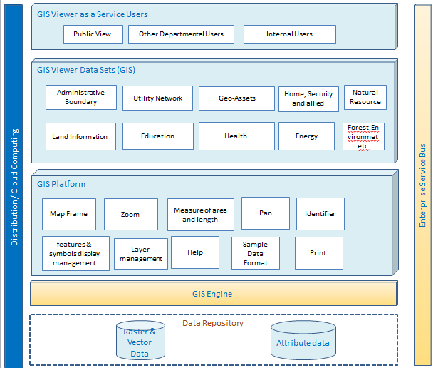

Intended Audience
This document is intended for following users
- Department Software Developers and the Technical staff using this “GIS viewer as a service”.

Definitions, Acronyms and Abbreviations

Sl No | Abbreviations | Descriptions
1 | GIS | Geographical Information System
2 | Lat | Latitude
3 | Long | Longitude
4 | AppUrl | Application URL
5 | API | Application Program Interface

What is GIS Viewer?
- An easy way to view and access maps and data.
- Optimized for simple and easy way to access maps and geospatial content.
- Secure private access
- View and access shared or public maps
URL syntax: http://<domain Name>/<serviceName>/
Sample Format: http://kgis.ksrsac.in/gisviewer/
Case 1: This shows you user can simply paste the URL and display the GIS Map window with Karnataka Map with Boundary layers and annotations viz. District, Taluk, Hobli, Village, Cadastral etc. in your browser as shown in Fig 1.
Case 2: When user access as a WebAPI in application code.
Step 1: Let us create a .NET based Web/Windows Application and create an event where the GIS Viewer API needs to be triggered/ Invoked.
Step 2: I have created a button click event and added the code.

Toolbar
The tools and their functions are:
Sl.No | Symbol | Functionality | Description
1 |  | Zoom in | Increases a zoom level of the map
2 |  | Zoom Out | Decreases a zoom level of the map
3 |  | Full Zoom out | Zoom to Full Map Extent
4 |  | Pan | Enables the user to interactively move the Map View position
5 |  | Identifier | Identify a feature on the map and show its attribute information
6 |  | Print | Exports the map with all visible features and base maps with user defined Title, Format and Layout
7 |  | Base Map Gallery | User can switch on to the selected base Map view like satellite, Google, Bing etc.
8 |  | Measuring Tools | Measuring tools allow interactive display of coordinates, distances and area on the Map View
9 |  | Layer List | Layer list shows list of layers in the map
10 |  | Coordinates | Display the current Longitude and Latitude coordinates of the cursor on the map.
11 |  | Legends | short description of what the symbol means
12 |  | Help | Displays/Download the help file of GIS Viewer
13 |  | Result | Result window/table showing the output
14 |  | Layer List | Layer list shows list of layers in the map

Functional Overview
The overall Web service for GIS viewer along with associated webservice is listed below.
The Web Services will provide access to populate and publish data and metadata REST service.

Single Latitude and longitude point

http://kgis.ksrsac.in/gisviewer/?latlong(Lat, Long)
To display a point on K-GIS Viewer based on latitude / longitude. (Units of lat /long shall be in decimal degree).
Dataset Format:
COLUMN NAME | DATA TYPE | VALIDATION FORMAT
Lat (Lattitude) | Float | Lattitude value should be greater than 11 and lesser than 19
Long (Longitude) | Float | Longitude value should be greater than 74 and lesser than 79
Error Messages:
Processing_Code | Processing_Status
101 | Invalid QueryString
102 | Input Value contains special characters
103 | Latitude value should be in between 74 and 79
104 | Latitude value should be in between 11 and 19
105 | Latitude contains special characters
106 | Longitude contains special characters

Sample Format: - http://kgis.ksrsac.in/gisviewer/?latlong(14.378,76.095)
Viewer/Data Display:
This web service shows the display of point on map as a graphic (green balloon symbol) with latitude and longitude as label as shown below .

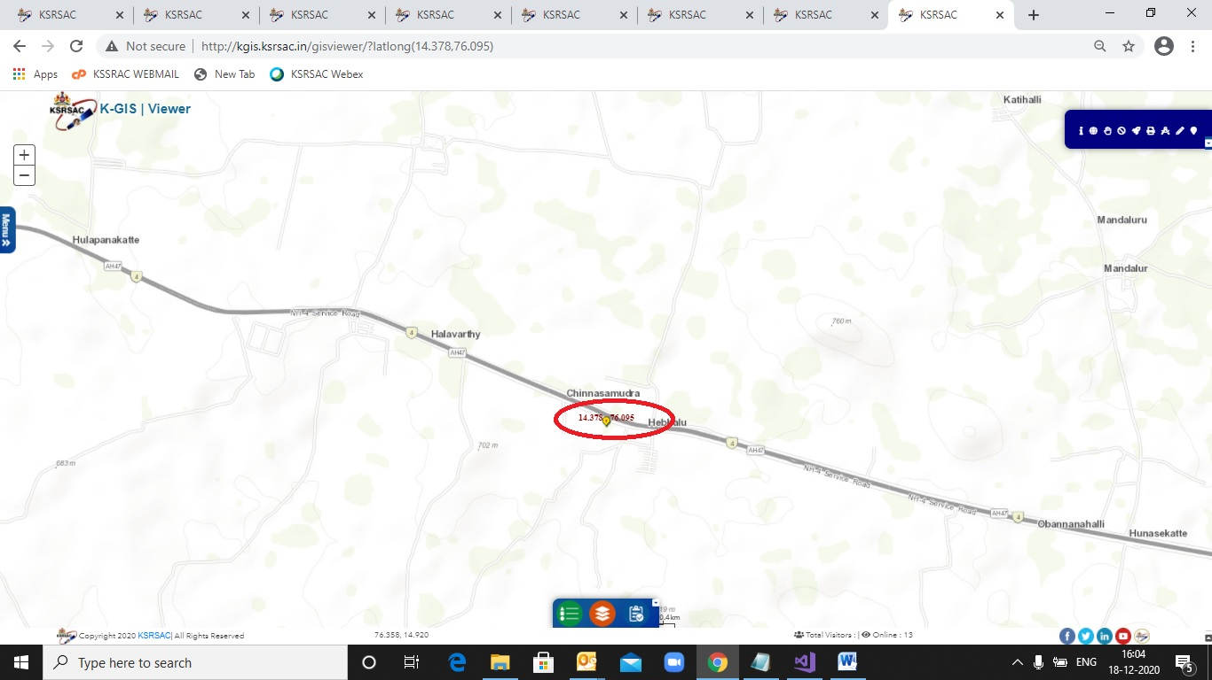

MULTIPLE LATITUDE and longitude points

http://kgis.ksrsac.in/gisviewer/?latlong(lat1, long1; lat2, long2; lat3, long3)
To display multiple points on K-GIS Viewer based on latitude / longitude. (Units of lat/long shall be in decimal degree). These points can be loaded with co-ordinates separated by semicolon.
DataSet Format:
COLUMN NAME | DATA TYPE | VALIDATION FORMAT
Lat(Lattitude) | Float | Lattitude should be greater than 11 and lesser than 19
Long(Longitude) | Float | Longitude should be greater than 74 and lesser than 79
Error Messages:
Processing_Code | Processing_Status
101 | Invalid QueryString
102 | Input Value contains special characters
103 | Latitude value should be in between 74 and 79
104 | Latitude value should be in between 11 and 19
105 | Latitude contains special characters
106 | Longitude contains special characters
Sample Format: - http://kgis.ksrsac.in/gisviewer/?latlong(12,77.56;12,77;13,77)
Viewer/Data Display:
This web service response displays the multiple points on map as a graphic (green balloon symbol) with latitude and longitude as label.
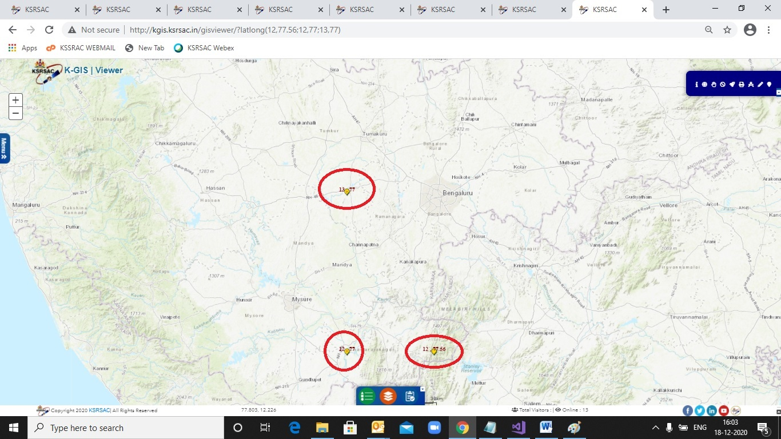

administrative boundary
Sample:
var x = new
{
InputDataJson = new[]
{ new
{
code="03",value="231",colorCodes="#ff6ef3",Allocation="90.65",Expenditure="30.22",Percentage="60.39"
},
new
{
code="02",value="5",colorCodes="#c6e2ff",Allocation="150.22",Expenditure="140.55",Percentage="60.39"
},
new
{
code="01",value="5",colorCodes="#0af9f6",Allocation="100.25",Expenditure="60.54",Percentage="60.39"
}
}
};
JavaScriptSerializer js = new JavaScriptSerializer();
string toolIds = "1,2,3,4,5";
string myJsonArr = js.Serialize(x);
string URL = "http://kgis.ksrsac.in/gisviewer/?classbreak=yes,tools=(" + toolIds + ")";
string MenuSideBar = "1,2,3,4,5";
string Method = "POST";
string AdminType = "01";
string CodeType = "02"; //KGISCode=03 //BhuoomiCode=02
string ColorCode = "Yes";
string Classbreak = "Yes";
string AppUrl = "";
string jsonObj = "{toolIds: ('"
+ toolIds +
"'),AdminType: ('"
+ AdminType +
"'),MenuSideBar: ('"
+ MenuSideBar +
"'),Classbreak: ('"
+ Classbreak +
"'),CodeType:('"
+ CodeType +
"'),ColorCode:('"
+ ColorCode +
"'), InputDataJson:JSON.stringify( "
+ myJsonArr +
"),AliasName:'Registration',NextActionText:'Back Next',AppUrl:'"
+ AppUrl +
"'}";
string script = "window.onload = function() { PostDataTest('" + URL + "','" + Method + "'," + jsonObj + "); };";
ClientScript.RegisterStartupScript(this.GetType(), "PostDataTest", script, true);
The method PostDataToKGIS() needs to be called either at client end or server end.

function PostDataToKGIS(action, method, input) {
console.log(input);
'use strict';
var form;
form = $('<form />', {
action: action,
method: method,
style: 'display: none;'
});
if (typeof input !== 'undefined' && input !== null) {
$.each(input, function (name, value) {

$('<input />', {
type: 'hidden',
name: name,
value: value
}).appendTo(form);
});
}
form.appendTo('body').submit();
Output:
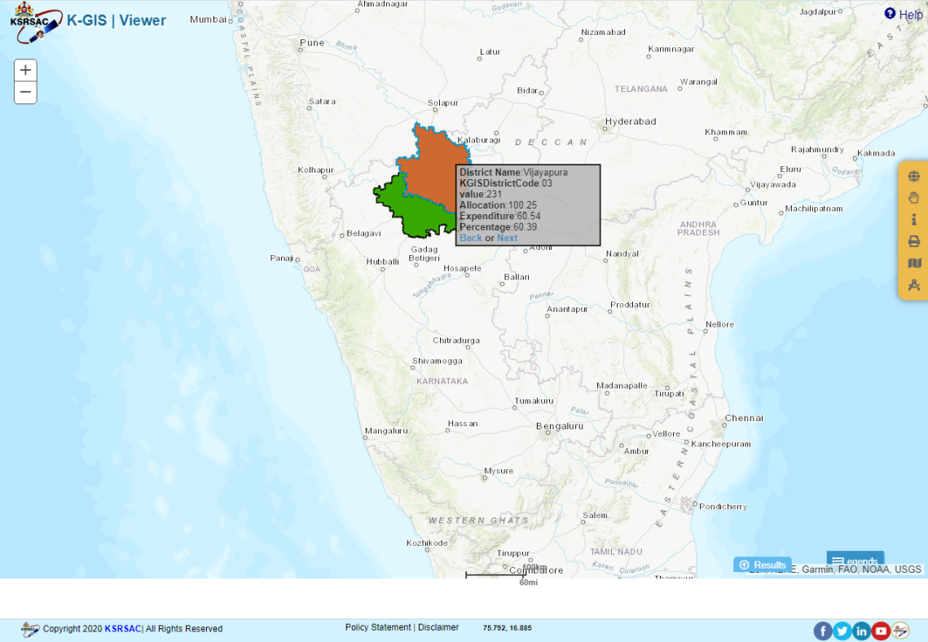
This web service will display the data of user choice can view on map as class break renderer.

SINGLE/Multiple LATITUDE and longitude points along with Admin boundaries and base map variants
This web service response displays the Single/multiple points onload map as a graphic (Yellow balloon symbol) with latitude and longitude as label along with the Admin Boundaries and base map Variant passed in the query string of the URL.
Eg: http://kgis.ksrsac.in/gisviewer/?VisibleLayers=Village,Hobli&latlong(13,75)&Basemap=K-GIS basemap
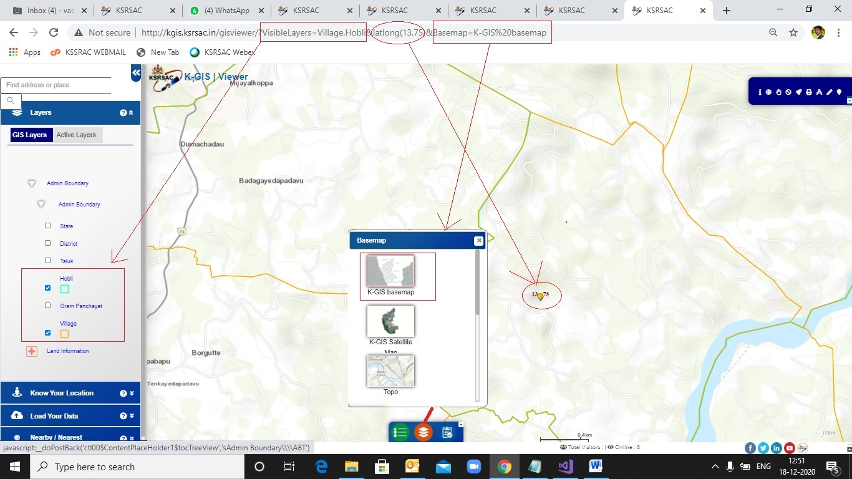
VisibleLayers-Key Word | Map Boundaries
State | State Boundary
District | District Boundaries
Taluk | Taluk Boundaries
Hobli | Hobli Boundaries
Gram Panchayat | Gram Panchayat Boundaries
Village | Village Boundaries
Cadastral Data | Cadastral Boundaries

Basemap -Key Word | Map Layers
K-GIS basemap | K-GIS basemap
K-GIS Satellite | K-GIS Satellite
Topo | Topo
Dark Grey | Dark Grey
Light Grey | Light Grey

