HELP DOCUMENT

Introduction

This application is to capture the Geo-Location of Social Welfare Work.

Background
Capturing of location coordinates of the Social Welfare Work and Geo-tagging of work progress.
Login Page
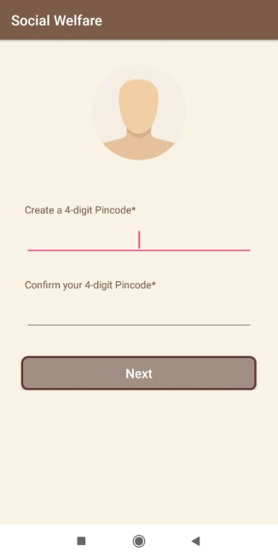
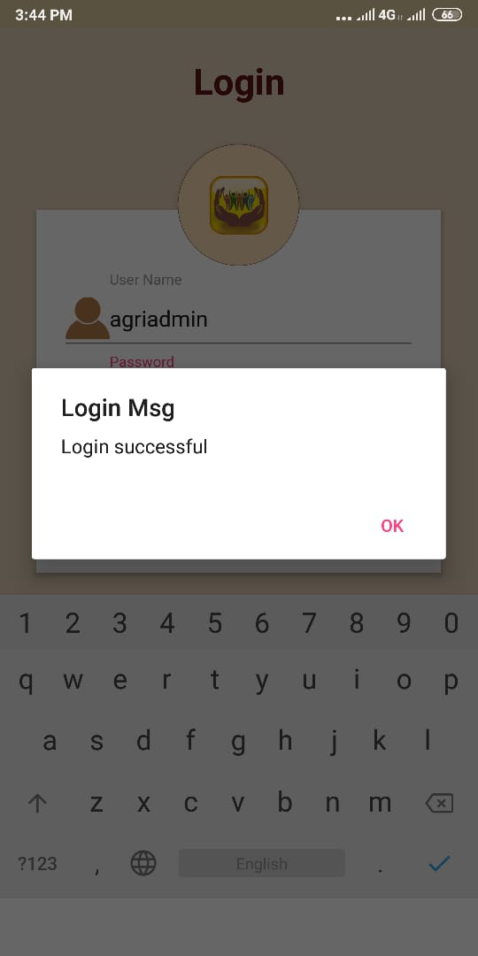
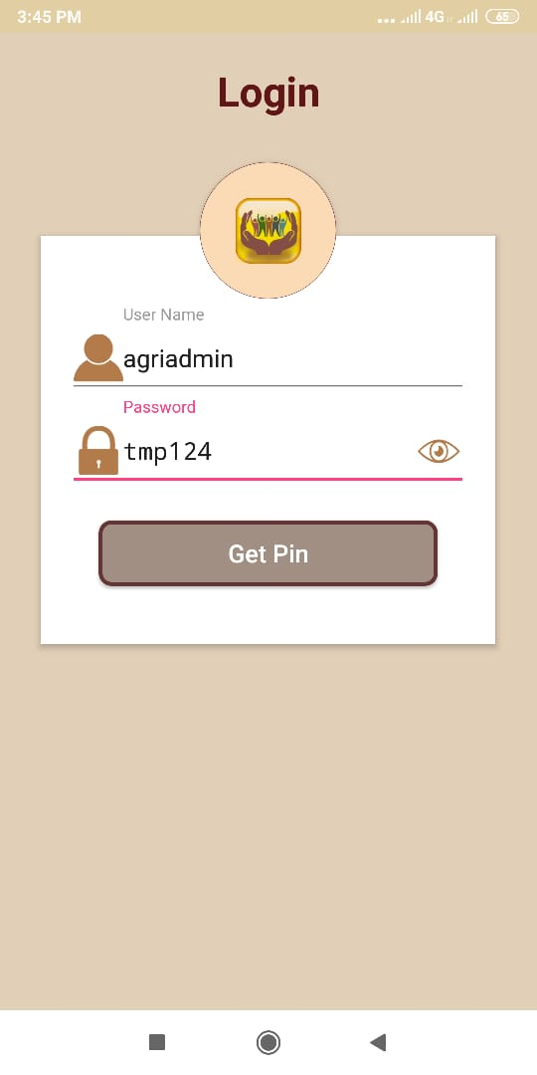

Log In (Login credential for Demo purpose)
  - User name : agriadmin
  - Password : tmp123

As soon as a User login, application allow user to set a 4 digit Pin for that login particular.

User will continue to use same login by entering 4 digit pin code once after creating Pin code.

- Enable / prompt to enable GPS of mobile after login
- Application is working in online/Offline.

User can only able to collect data in offline mode only if application paused after choosing work ID and map get loaded in phot collection page..

Note: By sending username, RoleId and Deptcd user will get the information based on the “Work Entry ID”.

Data Capture
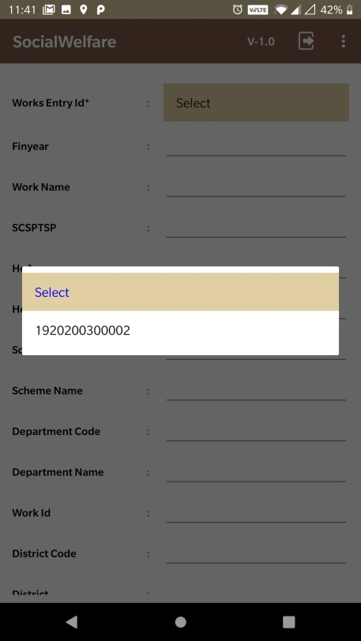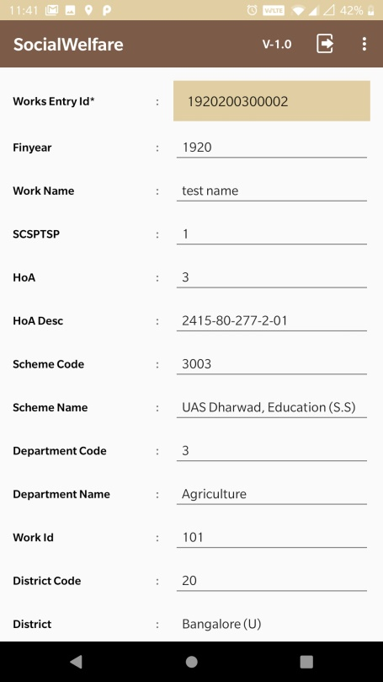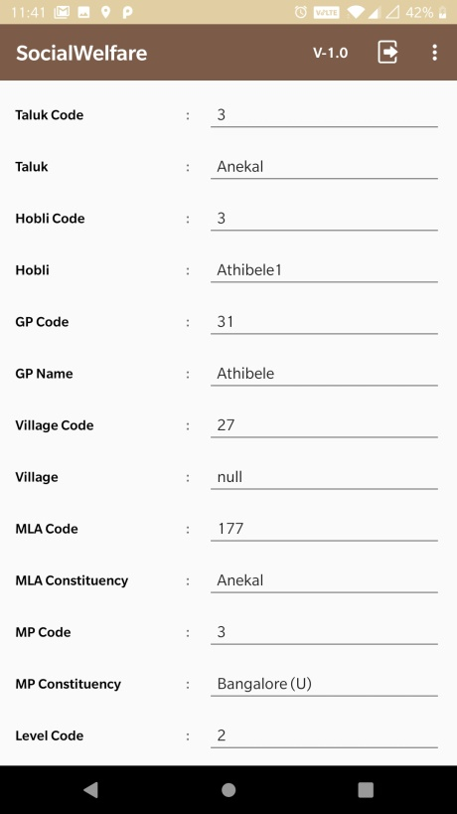
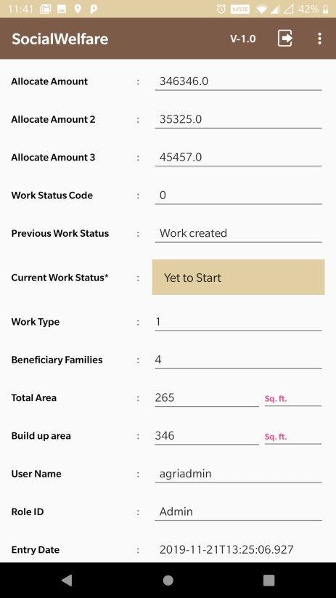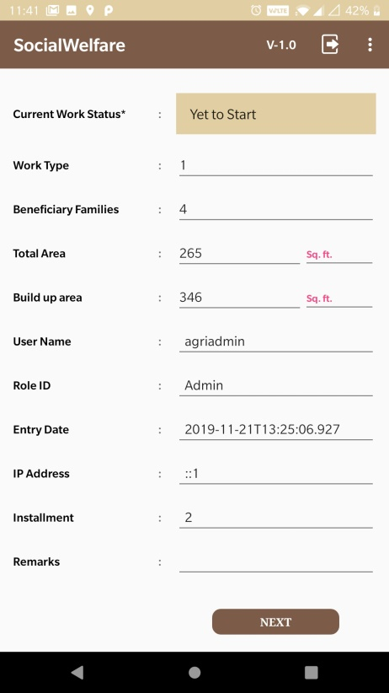

There will be four working status in the application as mentioned below.
- Work Created.
- Not Started.
- Progress.
- Completed.

If a new work ID created it has to pass through following steps:
Step 1: For the first time New Work created
- Previous Status will be in work created status.
- Current Status will be in Not Started status.

Step 2: If User had Sync data for current status Not Started previously.
If User login next time with fresh load of data. Same work ID which has completed Not started status will have.
- Previous Work status will be shown as Not Started.
- Current Work Status will be shown as Progress.

Step 3: If User had Sync data for current status Progress Previously.
If User login next time with fresh load of data. Same work ID which has completed Progress status will have.
- Previous Work status shown as Progress.
- Current Work Status shown as Completed.

Fig 1.1: Flow graph for Work ID Status

Once after a Work ID Complete data collection for current status as Completed, work ID will not be shown in Work ID list for Next Fresh load for any of the User.

By Selecting “Works Entry Id” user will get all the information of respective area where Work created.

To proceeds further user has to click on “Next” button.

Map View Activity

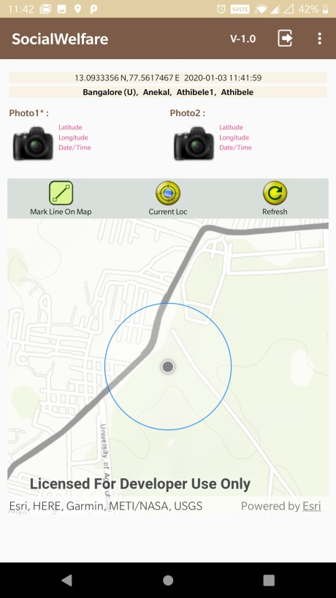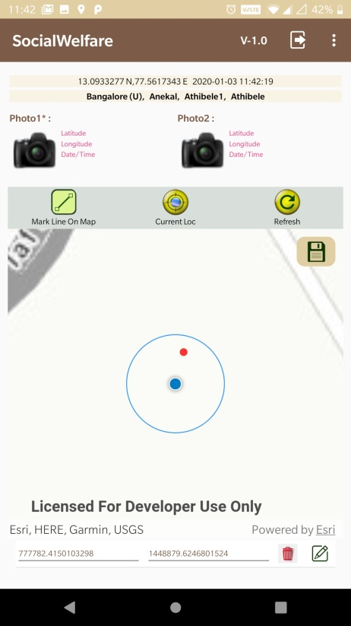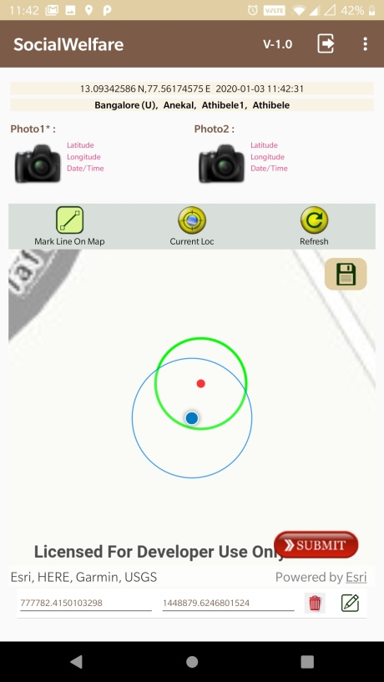
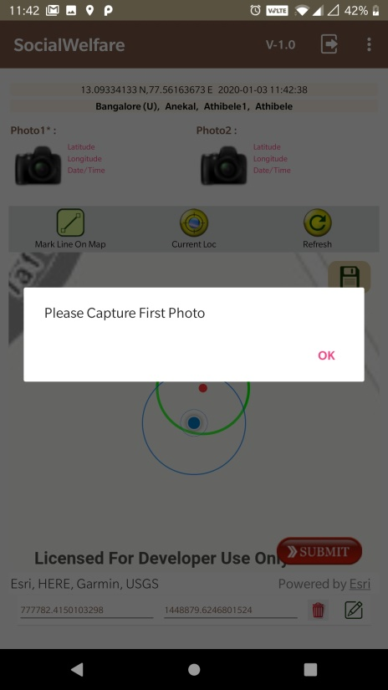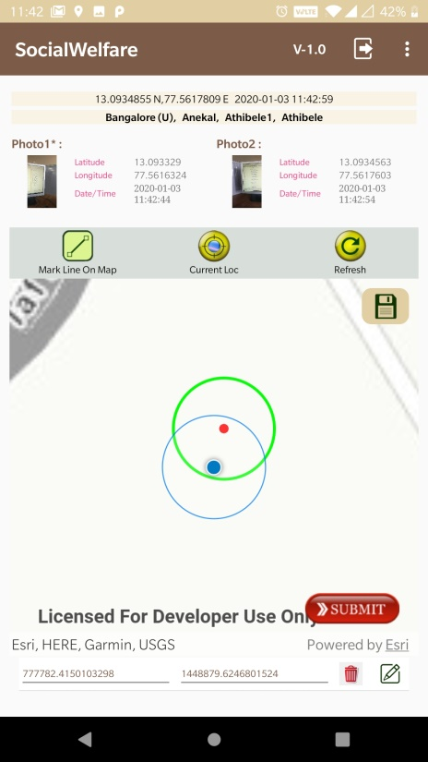
Through GPS user can able to find their current location. In this page there will be five image buttons.

- Mark Line On Map
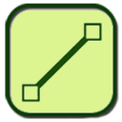
First time user has to collect/capture the geo-location of particular work by clicking on the “Mark Line On Map” image button (within the 100mtrs buffer).

- Current Loc
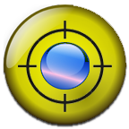
“Current Loc” image button has to be used to get user current location.

- Refresh
Refresh button used to refresh the data on Map

- Save
Save button will get visible only after click on “Mark line on map” to save the location information along with 30mts buffer which is represented in green colour.

- Submit
Submit button will get visible only after click on “Save” button to submit the location information. Before submitting the data “Capture First Photo” is mandatory.

Note: User should be inside the survey buffer to click the photo.

- Log out
Click on Logout button user will get logout from application.

If User on OK for logout then below page will be displayed for re-enter the pin which user has created during first login.

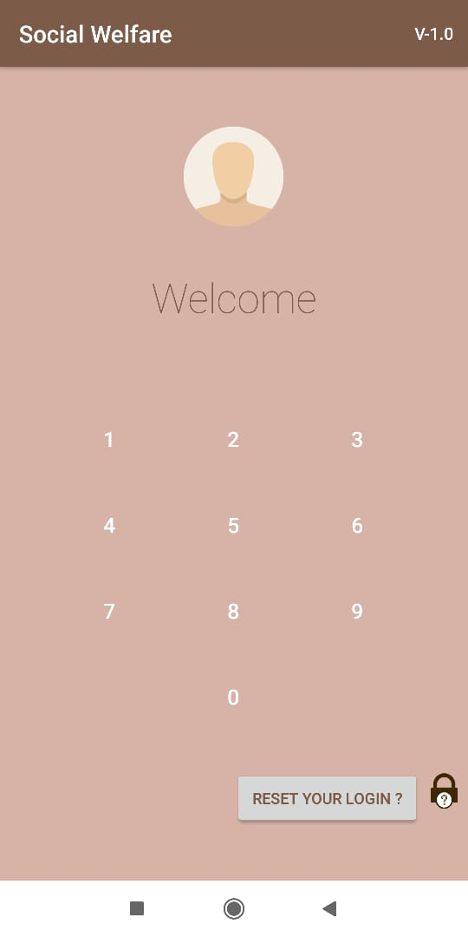

In above screen if user Click reset your login button user will be redirect to Login page.
Data collection flow:
Work Created: If work has been created by department then it will be assigned with work id and work related data will stored to database.

- Not Started: If Work current status in not started and previous status has Work created then user has to create buffer based on requirement
- Point
- Line
- Polygon
Once points has been taken on map user can able to save points once user able save points user can able to create buffer

Once buffer get created submit button will be enabled to save the buffer created for requirement.

- Progress: If Work current status is Progress and previous status has Not Started then user will be displayed with buffer which user had created when current status has Not started stage.

User has to click photos within green buffer boundary so has to make photo click valid.

Note: Point, Line, Polygon creation option won’t be displayed in further steps on screen.

- Completed: If Work current status is completed and previous status has Progress then user will be displayed with buffer within which user had created when current status has Not started stage.
User has to click photos within green buffer boundary so has to make photo click valid.

Data View
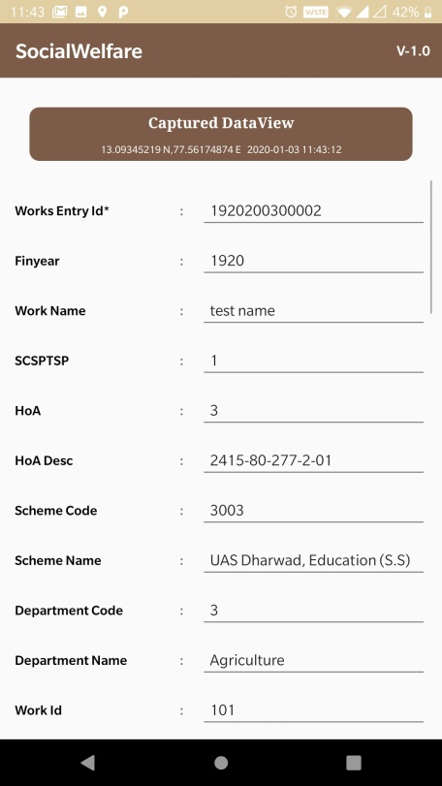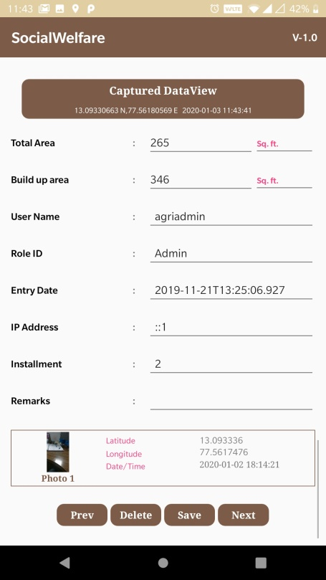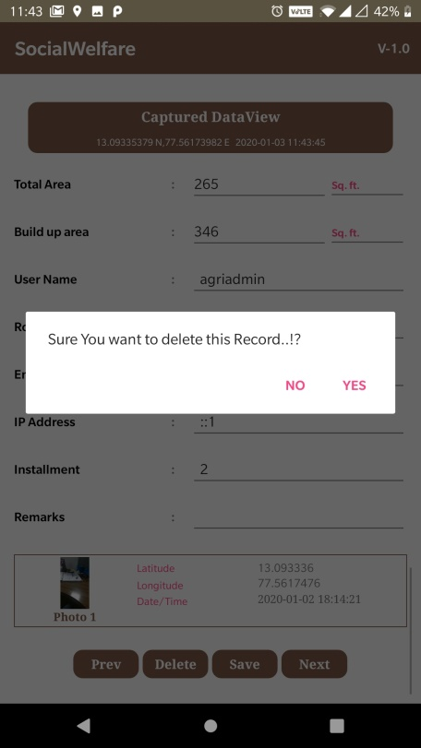

This is for viewing the collected data. There are 4 buttons like follows.
- Prevs (Button)This is for going to previous page
- Next (Button)This is for going to next page
- Delete (Button)This is for to delete the current page
- Save (Button) this is for saving the data after edit.

Note: If User deletes the record in data view page the same Work_Entry_Id has to be available in Work ID drop down for recollecting.

Sync page
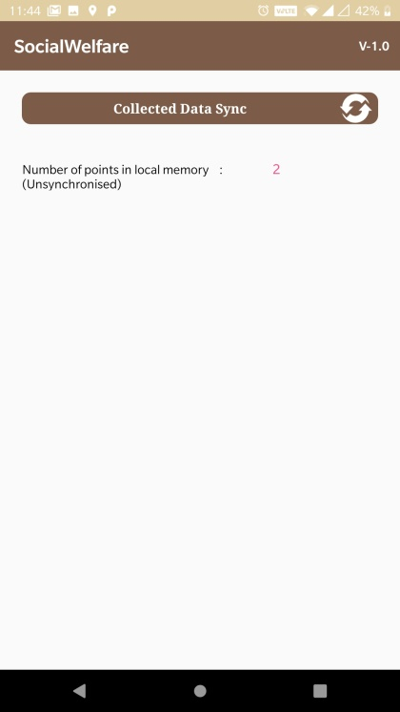
In sync page, the number of points collected is displayed. User has to sync data using sync button on the right upper corner. It’s kind of data wise count, here user can able to sync the records which are collected.

Sync Process:
if (collected data for particular Work ID and for particular current work status is not sync before)
{
Data will get sync to data base.
}

else if (collected data for particular Work ID and for particular current work status has been sync before In Data base)
{
Data fail to sync and Duplicate message will be displayed
}

Log out Button
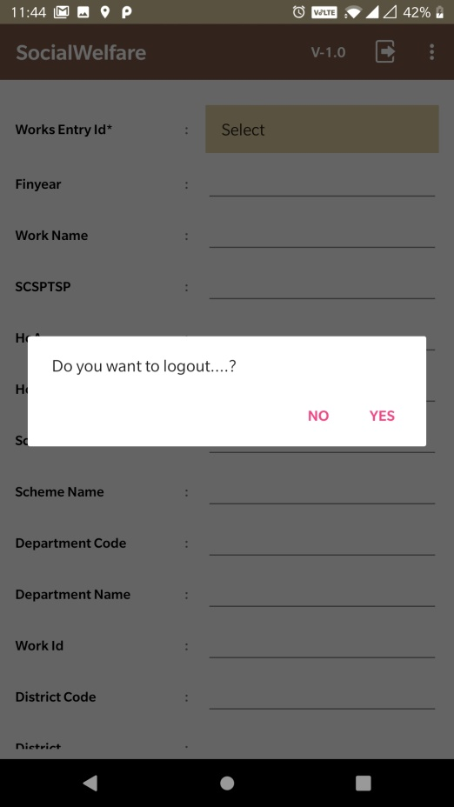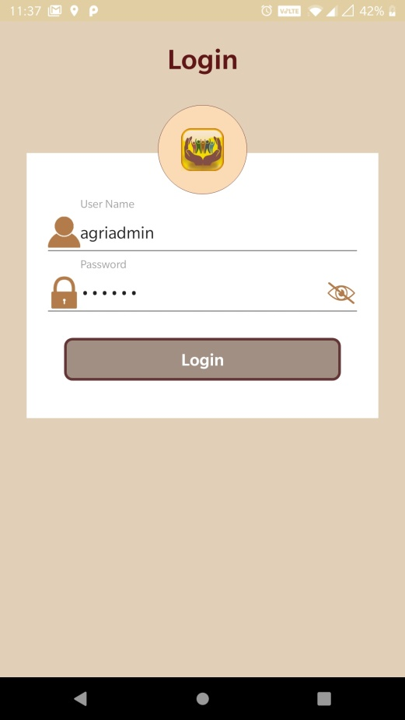
By clicking on logout button (which is on right corner of application page), it will asking for permission that whether user needs to logout. If it is yes means application will start from login activity.

